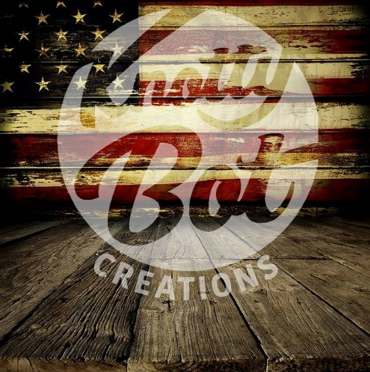
"No duty is more urgent than that of returning thanks."
- James Allen

Military & 1st Response members, thank you for your service and commitment!
I appreciate that you have made and make daily, sacrifices to help ensure our freedom and our safety. I would like to take this opportunity to show you a little gratitude by offering a special 10% OFF discount** to you and your immediate family members. I know that this could never repay the debt that we owe you as a country & community, but it is my little way of saying thank you!

Sincerely,
Randy Lavalley-Owner
Knotty Bot Creations, LLC.

**Discount Details:
- All active or reserve duty Military and Military Veterans and Police, Fire, & EMT’s are eligible
- Proof of a valid service ID must be verified before the discount is applied (current Military ID Card, VA health care card, VA issued ID Card, state driver’s license with a veterans designation, a Veterans Organization Card (e.g., DAV, American Legion, VFW, etc.), DD214
- Discount valid to 1 customer, per household, per month
- Discount cannot be combined with any other discount
- Discount is NOT valid for pending orders or previous purchases
- Discount does not apply restoration, repurposing or
- Offer subject to change or cancelation any time without notice or obligation by Knotty Bot Creations, LLC’s discretion

